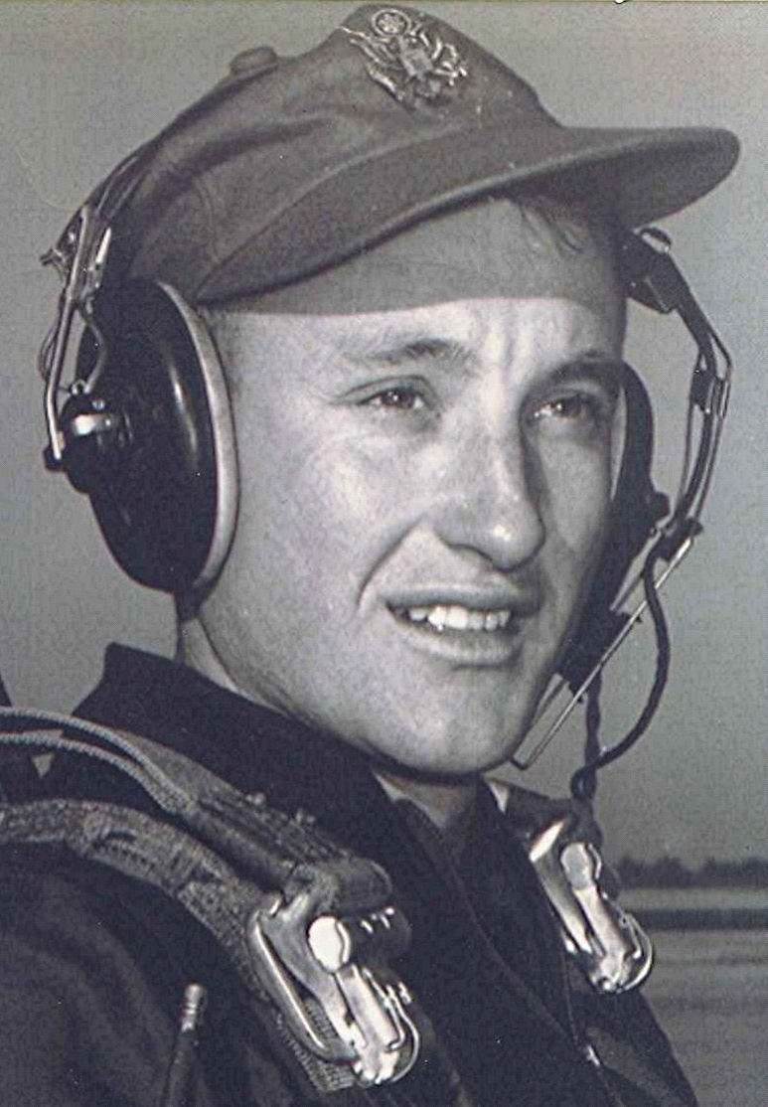
October Delectations
October 1997
Reflecting upon things past and things to come, it occurred to me that our class has been the obvious recipient of some sturdy genes. Evidence of this is the fact that most of those I know of are still able to go and come and do pretty much as they wish. I know, there has been a close call recently. Billy Joe, to whom we owe many hours of enjoyment as we listened as he recited from his almost photographic memory. Conversations that the rest of us have long forgotten. Our wishes are for a speedy recovery from his five-bypass heart operation.
Now, I realize that in some cases, parts have begun to wither and maybe even fall off or become non- functional, (for more specifics send a self-addressed, stamped envelope) but overall, I am thankful that, to paraphrase a friend from a long time ago, "I have come so far with so little with which to work."
May all your possum hunting be productive and your searches for persimmons and chinquapins be successful.
Xanthippus

Persimmons Chinquapins
